Indian School Al Wadi Al Kabir
Assessment 1
SOCIOLOGY (Code:039)
Class: XII Time: 1 Hour
Date:28/05/2023 Max. Marks: 30
General Instructions:
1. The question paper is divided into three sections.
2. There are 16 questions in all. All questions are compulsory.
3. Section A includes question No. 1-10. These are objective type questions carrying 1mark each
4. Section B includes question No. 11-13. These are very short answer type questions carrying 2
marks each. Answer to each question should not exceed 80 words.
5. Section C includes question No.14-15. They are short answer type questions carrying 4
marks each. Answer to each question should not exceed 120 words.
6. Section D includes question No.16. They are long answer type questions carrying 6 marks
each. Answer to each question should not exceed 300 words. There’s an internal choice in Sections B, C&D. Please write answers on selected questions only.

 | SECTION A
1. | What factors help in controlling epidemics?  - Improvement in medical cure for certain diseases  - Programmes for mass vaccination  - Efforts to improve sanitation facilities  - All of the above | 1
2. | Assertion (A): The migration of men from the villages of the Himalyan regions can lead to an unsual proportion of women -headed families in the villages  Reason (R): The internal structure of a family is usually related to other structures of society, namely political, economic, cultural etc.  - Both A & R are true and R is the correct explanation of A  - Both A & R are true but R is not the correct explanation of A  - A is true but R is false  - A is false but R is true | 1
3. | Patterns of unequal access to social resources are commonly called ______  - social morbidity b. social pressure c. social inequality d. social justice | 1
4. | “Famines were also a major and recurring source of increased mortality.” Which of the following is not a cause of famines?  - Continuing poverty and malnutrition in an agro-climatic environment.  - Inadequate means of transport and communication  - Failure of entitlements  - Increasing birth rates | 1
5. | Which of the following make the Dominant Castes dominant?  - Small population  - Land rights  - Intermediate caste  - Decisive role in regional politics  - I and II  - I and III  - II, III and IV  - I and V | 1
6. | Historically the caste system classified people by their ______  - education and income b. occupation and status c. race and gender  d. purity and pollution | 1
7. | Assertion (A): The Population Pyramid shows a bulge in the middle age groups, due to opportunity provided by the demographic structure.  Reason (R): This is due to high birth rate in the middle age groups.  - Both A & R are true and R is the correct explanation of A  - Both A & R are true but R is not the correct explanation of A  - A is true but R is false  - A is false but R is true | 1
8. | The ________ family is often seen as symptomatic of India.  - Nuclear  - Patriarchal  - Patrilineal  - extended | 1
9. | The person who is refused a job because of his/her caste may be told that he/she was less qualified than others and the selection was done purely on merit. This is an example of -  - discrimination  - social stratification  - egalitarianism  - stereotype | 1
10 | Person from a well-off family can afford expensive higher education. Someone with influential relatives and friends may- through access to good advice, recommendations or information- manage to get a well-paid job.  Which if the following is true in the given context?  - There are multiple forms of capital  - Different forms of capital cannot be converted into the other  - The forms of capital overlap  - I is false  - I and II are true  - I and III are true  - I, II and III are true | 1
 | SECTION B
11. | Why is the Malthusian theory of population criticised?  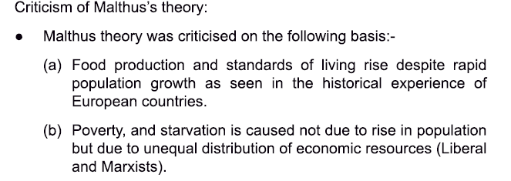 | 2
12. | “In both English and Indian fictional writings, we often encounter an entire group of people classified as ‘lazy’ or ‘cunning’.” What are the problems with such a classification?  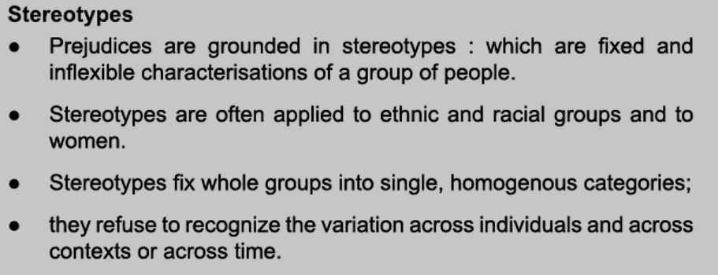  OR  What is the difference between assimilationist and integrationist policies?  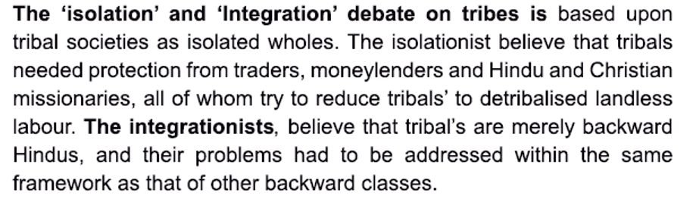 | 2
13. | What is untouchability?  Untouchability is a social practice within the caste system in which members of the lowest castes are thought to be ritually impure to such a limit that they cause pollution by mere touch or even sight. Untouchable castes are at the bottom of the hierarchical system. These low castes are excluded from most social institutions.  It is an extreme and vicious aspect of the caste system. It uses stringent social and ritual sanctions against members of castes located at the bottom of the purity pollution scale. They are considered to be outside the caste hierarchy. | 2
 | SECTION C
14. | Discuss India’s demographic achievement since independence.  OR  Why did Malthus believe that catastrophic events like famines and epidemics that cause mass deaths were inevitable?  English political economist Thomas Robert Malthus argued that human population tend to grow at a much faster rates than the rate which the means of human subsistence (land, agriculture) can grow.  He said population rises in geometric progression whereas agricultural production can only grow in Arithmetic progression.  Malthus believed that positive checks to population growth in the form of famines and diseases, was inevitable. These are nature’s way of dealing with the imbalance between food supply and increasing population.  According to him, these natural checks are extremely painful and difficult. Although it helps to achieve a balance between population and subsistence by increasing the death rate. | 4
15. | One of the most significant yet paradoxical changes in the caste system in the contemporary period is that it has tended to become ‘invisible’ for the upper caste, urban middle and upper classes. For these groups, who have benefited the most from the developmental policies of the post-colonial era, caste has appeared to decline in significance precisely because it has done its job so well. Their caste status bd been crucial in ensuring that these groups had the necessary economic and educational resources to take full advantage of the opportunities offered by rapid development. In particular, the upper cate elite were able to benefit from subsidized public education, especially professional educations in science, technology, medicine and management. At the same time, they were also able to take advantage of the expansion of state sector jobs in the early decade for Independence.  - What is caste? (2 marks)  The term caste is derived from the Portuguese word ‘casta’ which means pure breed. In other words, it also means a group/community of people. Caste is also called ‘jati’. Caste can also be described as a segmental division of stratification in society acquired by birth.  According to G.S Ghurye, “caste is a segmental division of society having a hierarchy of groups, professing a fixed occupation, having allied and religious disabilities and privileges with restrictions on marriage, feeding and social intercourse. It is an endogamous group determined by birth.  - ‘For the so-called scheduled castes, tribes and the backward classes’, the opposite of what is mentioned in the passage as being true for upper caste and class has happened. For them caste has become all too visible. Explain why this is so. (2marks)  The changes in the caste system benefited the most were urban middle and upper class. Caste status ensured these groups the necessary economic and educational resources and they took full advantage of the opportunities offered by rapid development. Particularly the upper caste elite were able to benefit from subsidized public education, especially professional education in science, technology, medicine and management. They were also able to take advantages of the expansion of state sector jobs in the early decades after independence. Because of this earlier load over the rest of the society in terms of education ensured a privileged status.  For the so-called SC and ST and backward castes this change became detrimental. For these the caste became all too visible. They had not inherited educational and social capital and they had to compete with already established upper caste group. They cannot afford to abandon their caste identity. They continue to suffer from discrimination of various kinds. | 4
 | SECTION D
16. | 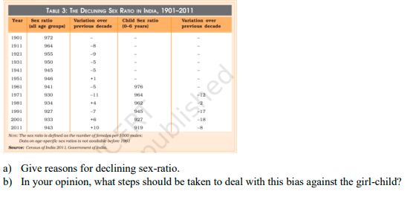  Question 1:  OR  Sex ratio refers to the number of females per thousand males in a given area at a specified period of time.  •This ratio is an important indicator of gender balance in population.  •Historically there were more females than males in most countries of the world. This phenomenon occurred due to two reasons:  (i)Girl babies enjoy better immune system and resistant to diseases in comparison of male child.  (ii)Females live longer than males in most of the societies.  •The ratio between female babies and male babies is roughly 1050 female to 1000 male.  •In India sex ratio is declining significantly and continuously for more than a century. From 972 female per thousand males at the turn of 20th century the sex ratio declined to 933 at the turn of 21st century.  •The state level child sex ratio is alarming. As many as 6 states and union territories have a child sex ratio as low child sex ratio of 793. The highest child sex ratio of 986 is found in Sikkim.  Sex ratio seems to be declining in countries like India, China and South Korea.  In India, parents still prefer male child. This is basically due to social and cultural reasons. Being agricultural society the village population preferred male child to look after the land. The reason of preference of male child is definitely not linked with economic reasons. The states like Punjab, Haryana, Delhi, Chandigarh and Maharashtra are most prosperous states of India and should have highest child sex ratio, but things are just different.  The census of 2001 reveals that these are states with the lowest sex ratios i.e., 950 female babies per 1000 male babies. This data is a reliable evidence that selective abortion in these states is not due to poverty, ignorance or lack of resource. Predisposing factors for low child sex ratio in India:  •Religious or Cultural Beliefs: Belief that only son is entitled to perform funeral and related rituals of his parents. Only son is the waaris (heir) of family. In the absence of male child, the lineage will not continue.  •Economic Reasons: The main occupation of Indian society is agriculture. Villagers have a thinking that landed property cannot be given to girls because after marriage they will go to another village, town or city. Neither girl child can get her share of load nor she can take care of the land.  •Lack of Awareness: People in Indian society having ignorant conservation attitude are still not ready to give equal status to daughter because they think that during old age they will be dependent on the son. Only he will share food, house, customs and responsibilities.  Implications of child sex ratio: Low child sex ratio, if continues, will have serious implications on our social network, particularly the Institution of marriage. It will also cause severe law and order problem related to women.  Question 2: What are the major concerns regarding the Adivasis today? | 6

